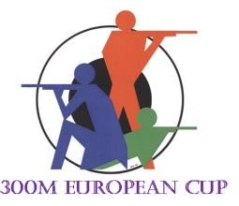  
LAPUA EC Denmark 2025
Free training
18.08. 09:00-12:30
Firing point | NOC | Athlete
1 | - | Not in use
2
3
4
5
6
7
8
9
10
11
12
13
14
15
16
17
18
19
20 | - | Not in use

